Comparative Analysis of Machine Learning-Based Intrusion Detection Systems for Secure IoT Networks
16010423001-Aakanksha Gangaramani 16010423001-Ananya Rao
1601042344-Kaavya Joseph 16010423053-Minal Sinha

1. Introduction
This document presents the dataset details and implementation aspects of the intrusion detection system developed for IoT networks. The study focuses on analyzing network traffic data using machine learning techniques to detect various types of cyber-attacks. The dataset used in this work is a standard benchmark dataset widely used in intrusion detection research.
2. Dataset Description
The NSL-KDD dataset has been used for this study. It is an improved version of the KDD Cup 1999 dataset and is designed to remove redundant records and provide a balanced evaluation platform for machine learning models.
The dataset consists of two files:
- KDDTrain+ (125,973 records)
- KDDTest+ (22,544 records)
Each record contains 41 features along with a class label. These features include both numerical and categorical attributes such as protocol type, service, and traffic statistics.
The dataset is classified into five major categories:
- Normal
- Denial of Service (DoS)
- Probe
- Remote to Local (R2L)
- User to Root (U2R)
3. Dataset Structure
The dataset consists of a combination of categorical and numerical features. These features represent different characteristics of network traffic. The structure allows classification of data into multiple categories, making it suitable for intrusion detection tasks.
Figure 1: Dataset Dimensions
4. Preprocessing Applied
Before training the machine learning models, preprocessing steps were performed. Categorical features such as protocol type, service, and flag were converted into numerical values using label encoding.
Additionally, Min-Max normalization was applied to scale all feature values within a range of 0 to 1. This ensures that all features contribute equally during model training.
5. Dataset Usage in This Study
The KDDTrain+ dataset was used for training the machine learning models, while the KDDTest+ dataset was used for evaluation. This ensures that the models are tested on unseen data.
The dataset was used without applying advanced techniques such as SMOTE. As a result, class imbalance is present, particularly for minority attack classes such as R2L and U2R.
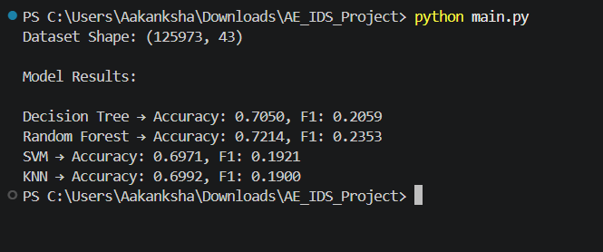
6. Summary
The NSL-KDD dataset provides a suitable benchmark for evaluating intrusion detection systems. It allows testing of machine learning models on multi-class classification problems. However, class imbalance remains a challenge and affects the performance of the models.

